Исследовательский проект

Тема: «Traditions of tea- drinking in England and in Russia»

Автор работы:
Морозова Александра,4 класс,
МКОУ «Шебертинская СОШ»

Руководитель:
Винокурова Светлана Сергеевна

2020

Traditions of tea- drinking in England and in Russia.
The topic of the work is the study and analysis of English and Russian tea traditions.
The relevance of the chosen topic is that:
-it is impossible to get a true picture of England without getting acquainted with its culture and traditions, the most striking of which are the traditions of tea;
-the study of traditions brings up a person’s curiosity about the history of their own country;
-comparing the traditions of the contributes to understanding their culture.
The hypothesis: if in England and in Russia there are centuries – old traditions of tea drinking, then there are rules of tea drinking the etiquette that English and the Russians follow.
My purpose of the work explore the traditions of English tea drinking as part national culture of the country and compare with the traditions of tea drinking in Russia.
My tasks:
-find and study material about the Russian and English tea traditions;
-identify the features of tea traditions in England and Russia
The results of the research should be presented in the form of a research paper on country studies.
The object of the study is tea traditions.
The subject of the study is the culture of tea drinking in England and Russia.
My methods:
1. Theoretical
- Collection of information
- Analysis and comparison of traditions in England and Russian cultures
2. Practical
-Sociological serve
-Generalization of date

The table of contents
Introduction
1. The history of tea.
1.1 The emergence of tea in England.
1.2 The emergence of tea in Russia.
2. Tea drinking traditions in England and Russia.
2.1 Features of the traditions of English tea drinking.
2.2 Features of the traditions of Russian tea drinking.
2.3 Similarity and difference of tea drinking traditions in England and Russia.
3. Statistics of the tea party.
4. Explanatory dictionary.
5. Conclusions.
6. References
7. Applications
Introduction

The history of tea.
Today, there are about 248 countries in the world. And each of them is individual in its own way. Each nation has its own traditions and traditions customs. Tea – one of the most popular drinks in the world.
It is believed that tea was discovered by the Chinese emperor about 5000 years ago.
There is legend that Shen Nounou tired by the evening decided to boil water. Tea leaves got into it. This case he initiated a more thorough study of the properties of the new tool.
Conclusion: The appearance of tea has your own history.

The emergence of tea in England.

The first documentary evidence of tea was presented in newspaper advertisement by Toms Harvey, published in 1658.The article indicates the main advantages of tea:
Tea gives – you strength and energy;
-it eliminates fatigue apathy;
-normalizes sleep, helps to overcome drowsiness
English tea drinking traditions have a long history. Tea was brought to England in the seventeenth century by a Portuguese princess, who married king Charles of England has been popular in the country ever since.
Conclusion: English tea drinking has a long history that is very popular nowadays.
The emergence of tea in Russia.

In Russia, tea appeared in the early 17th century. It was presented to the Emperor Mikhail Fedorovich Chinese ambassadors. After tasting the tart taste of the drink, he concluded a trade agreement. In 1900, the popularity of tea increased so much that its own tea was founded prints in 20 years plantations.
Tea in Russia was served from a boiling pot and tea server called a samovar. This became the center of the Russian household. Generally, tea was served strong, but sweetened. In spite of the interference of the Russian Revolution and the disruption caused by civil war, tea remained popular. Today it is still one of the leading beverages in the country.
Conclusion: The history of tea in Russia count more than one hundred years nowadays.
Features of the traditions of English tea drinking.(приложение №1)

For the British, a tea party is not just an ordinary thing, but a whole ceremony that has its own traditions. They are honored until our time, passed down from generation to generation and will always be held in high esteem.
There are lot traditions of the tea ceremony in England. Every detail is important here: from what should be the size of the cake and the type of tea, and what dishes are used. Even the time for tea is different.
Time for English tea.
There is a special time for the tea ceremony in England because they enjoy drink several times a day:
The first cup of black tea is drunk immediately after waking up, at about 6 o’clock in the morning.
The second time tea party takes place during the «English Breakfast», somewhere at 8 o’clock in the morning.
At half past eleven, you can have tea again. It’s coming lunchtime.
At the height of the working day, at 4 o’clock in the afternoon, there is a «tea break».
Literally an hour later, at 5 o’clock in the evening, the «five – o’clock» comes. Huge numbers of people in England gather for a cup of tea.
At the end of the working day, so stressful and difficult, you need to stop a little. Drink a cup of tea and think about the day went and what he gave the person. It is important to relax and enjoy your free time.

Milk for tea.
The English tradition of diluting tea witch milk has successfully caught on with us. Adding warm milk to tea has become an important part of the English tradition of British tea culture. Milk is served in a special milk jug; which is mandatory attribute of any tea ceremony in England.

Conclusion: The tradition of English tea - drinking is very popular. The routine in England is built from tea - drinking to tea- drinking.

Features of the traditions of Russian tea drinking.(приложение№2)
Tea is an extremely significant part of Russian culture. Tea in Russia is not just a beverage- it’s a social activity witch a long- reaching tradition behind it.
Tea is popular in many countries and each country has own traditions and preferences in drinking of tea. Russia is the where tea- drinking formed into individual tradition.
In Russia tea is served after meals and during mid- afternoon breaks a kind of English «five – o’clock - tea» with difference that this Russia «five - o’clock - tea» may occur in any part of day and in any place- in office, in car, in a park.
When friends visit somebody hosts invite them to have a cup of tea. This cup of tea is not just a tea but lots of cookies, sandwiches, and other meal. Each feast ends with tea- drinking with candies and cakes.

Conclusion: Russian tea – drinking is an inalienable and very important part in Russian life. Russian people drink this fine beverage three centuries nowadays.

Difference:
1. In England, first of all, the style is important, the atmosphere of the house as a whole. The main thing in Russian tea drinking is an atmosphere of warmth, fun, peace and joy.
2. In Russia, black tea is traditionally drunk, and England, according to the tea etiquette, it is absolutely necessary to offer the guest several varieties of tea to choose from.
3. In England, they prefer elongated forms, and Russia they prefer to drink tea from pot- bellied cups.
4. In Russia, people often drink tea from a glass in a cup holder, whereas in England this subject of the tea - table was missing.

The main part.

As a result of the research at this stage, I conducted a survey among the population of different ages on the following questions:
1. Do you drink tea (yes, no)?-Приложение №3
2. How often do you drink tea? Приложение №5
3. What kind of tea do you prefer? (Black, green, tea with fruit) Приложение №4

Conclusion:

Tea is an amazing drink. Tea is a regular guest on our table; we drink it at home, in cafes, on holidays on weekdays. This work was to compare the traditions of English and Russian culture. In the course of my research we were able to study and analyze English and Russian tea traditions based on the material of linguistic and cultural studies. I have found the necessary evidence for my hypothesis that English and Russian tea drinking have their own unique features. In the course of the study, all the tasks were completed. The goal of the project has been achieved as we have studied and compared the traditions of English and Russian tea parties. The materiel collected by me can be used in country studies classes, and can also be interesting and useful to all those who often travel, study English or are simply interested in studying the traditions of different countries.
A cup of tea is symbol of kindness and warmth.

СПИСОК ЛИТЕРАТУРЫ
Власова, И. В. Русские: история и этнография/В. А. Тишков. – М.:Олимп, 2008, 315с.
Книга о чае. Сер. «Азбука быта»/под ред. Е. А. Иванова. – Смоленск: Русич, 1996, 226 с.

Приложение №1
Features of the traditions of English tea drinking.
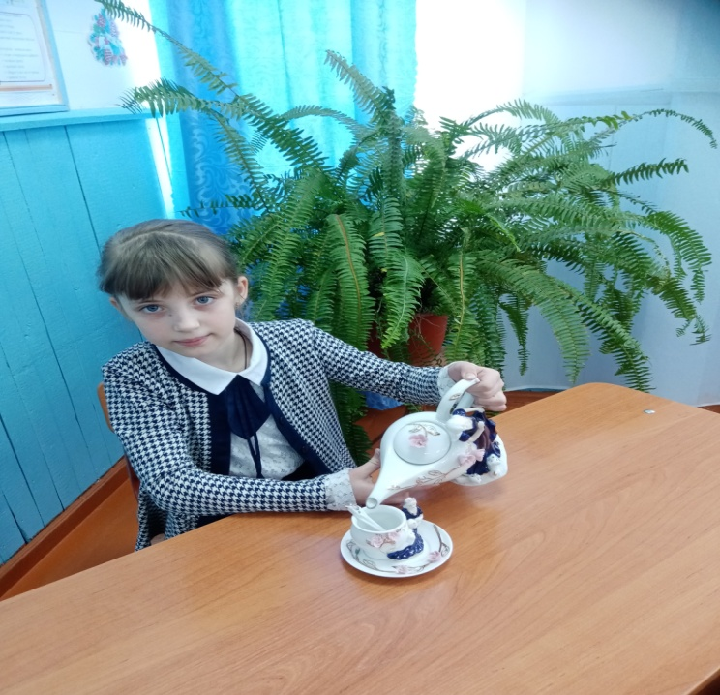

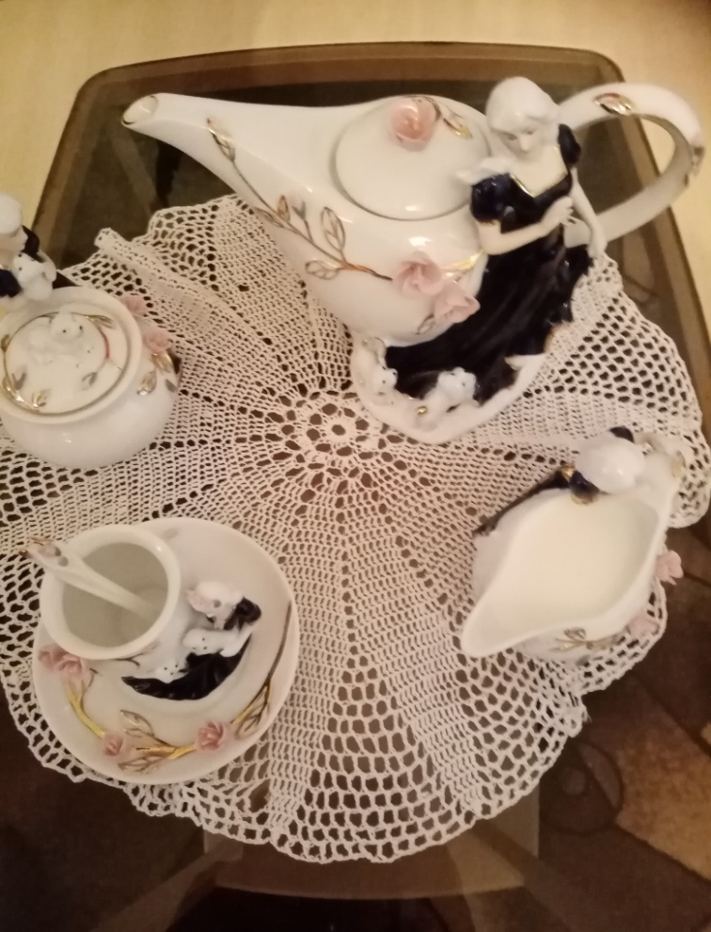

Приложение №2
Features of the traditions of Russian tea drinking.

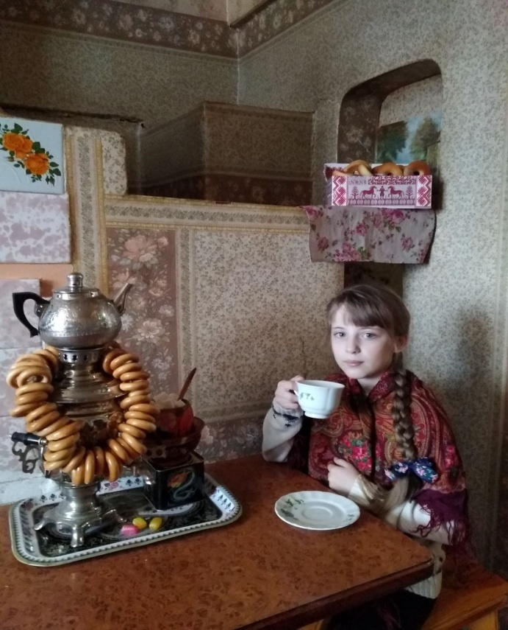
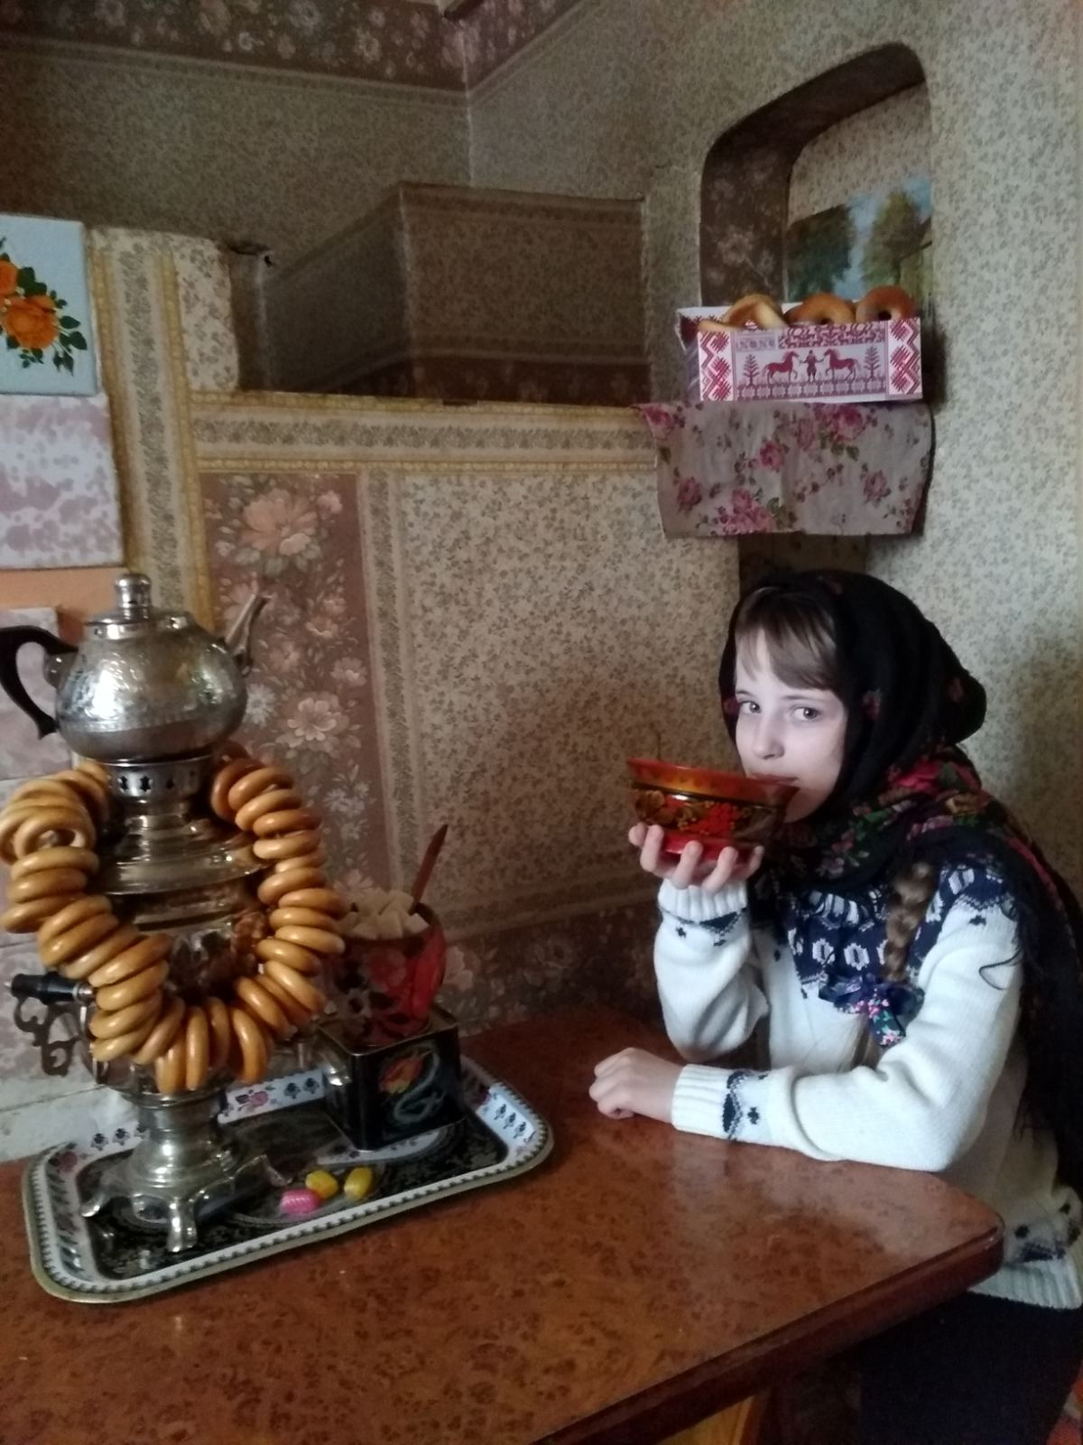

Приложение №3
1. Do you drink tea (yes, no)?

Приложение №4

3. What kind of tea do you prefer? (Black, green, tea with fruit)

Приложение №5

