**ОБЛАСТНОЕ БЮДЖЕТНОЕ ПРОФЕССИОНАЛЬНОЕ ОБРАЗОВАТЕЛЬНОЕ УЧРЕЖДЕНИЕ  
«КУРСКИЙ АВТОТЕХНИЧЕСКИЙ КОЛЛЕДЖ»**

**Ю.В. Бондарева**

**Профессиональный английский для студентов сварочного отделения (в формате требований WorldSkills)**

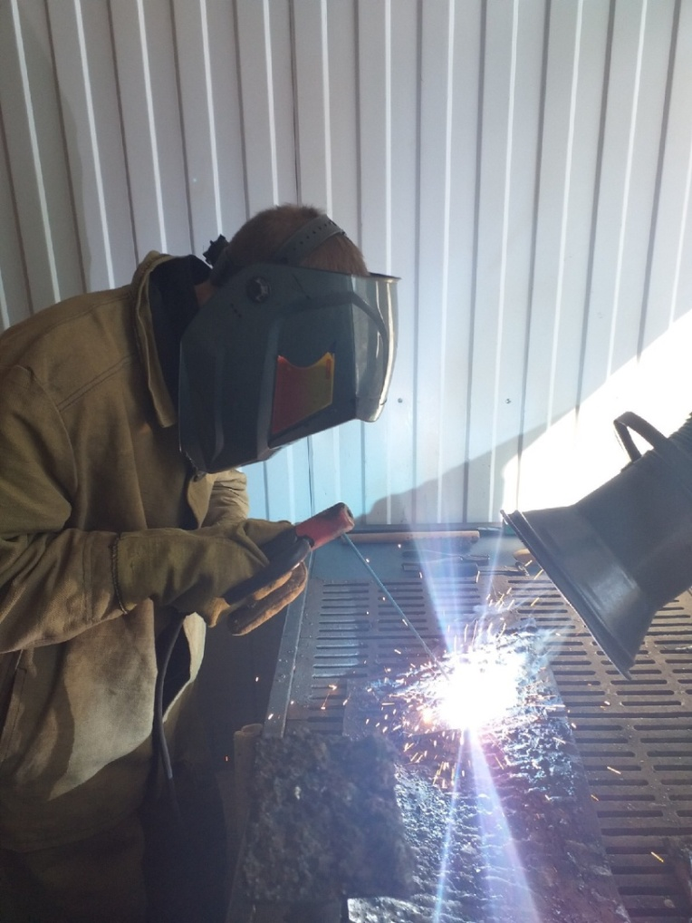**Методическое пособие для студентов**

**Курск 2019**

Рассмотрено на заседании цикловой

комиссии филологических дисциплин

Протокол № 7 от 28 февраля 2019

Председатель цикловой комиссии

______________ М.Н. Тарасова

Автор-составитель: Ю.В. Бондарева, преподаватель ОБПОУ «КАТК».

Профессиональный английский язык для студентов сварочного отделения (в формате требований WorldSkills) / сост. Ю.В. Бондарева. – Курск: ОБПОУ «КАТК», 2019. – 37 с.

Методическое пособие включают в себя аутентичные тексты по сварочным технологиям на английском языке, разноуровневые задания к текстам, направленных на расширение лексического запаса студентов. В методическом пособии представлен краткий справочник по сварочному производству, составленный с учетом требований WorldSkills, а также словарь профессиональной терминологии, предназначенный для активизации и закрепления профессиональной лексики посредством выполнения различных заданий и упражнений.

Методическое пособие предназначено для студентов сварочного отделения, изучающих английский язык.

Ю.В. Бондарева

ОБПОУ «Курский автотехнический колледж», 2019

Оглавление

Введение 4

Part 1. Job Description 5

Text 1. What Does a Welding Engineer Do? 5

Text 2. What Is Welding and What Do Welders Do 7

Part 2. Welding Processes 12

Text 1. Introduction to Welding Processes & Equipment 12

Part 3. Shielded Metal Arc Welding 16

Part 4. Gas Metal Arc Welding 21

Part 5. Flux-cored Arc Welding 25

Part 6. Gas Tungsten Arc Welding 27

Приложение 1 30

Welding Theory & Application Definitions 30

Приложение 2 33

Англо-русский словарь сварщика 33

Список литературы 37

# Введение

Настоящее учебное пособие предназначено для подготовки студентов, обучающихся на сварочном отделении. В пособие включены аутентичные тексты на английском языке по основной сварочной тематике с учетом требований конкурсных заданий «WorldSkills». Тексты, которые вошли в пособие, заимствованы из английских, американских и российских учебников и пособий по сварочному производству, на основании которых был составлен краткий справочник и англо-русский словарь сварочных терминов.

Данное пособие нацелено на развитие навыков устной и письменной речи и чтения литературы по специальности на английском языке.

В настоящее время сварочное производство по праву считается одной из популярных компетенций чемпионата WorldSkills. Участие в конкурсах подобного уровня подразумевает не только владение профессиональными навыками и умениями, а также знание английского языка. Для студентов, участвующих в Чемпионате WorldSkills, знание английской терминологии по специальности поможет сократить время на ознакомление с заданиями Чемпионата, представленными на английском языке.

Пособие снабжено иллюстративным и справочным материалами и может использоваться как для аудиторной, так и для самостоятельной работы студентов.

# Part 1. Job Description

## 

## Text 1. What Does a Welding Engineer Do?

**Pre-reading**

***I. Find the Russian equivalents for the words and word combinations in italics in the text.***

The typical **welding engineer** has many responsibilities. Welding engineers use a variety of professional tools, machines, and other types of **equipment** to execute different welding tasks. Some of the main duties of these engineers are to optimize welding processes, plan for strategic improvements, and maximize company profitability.

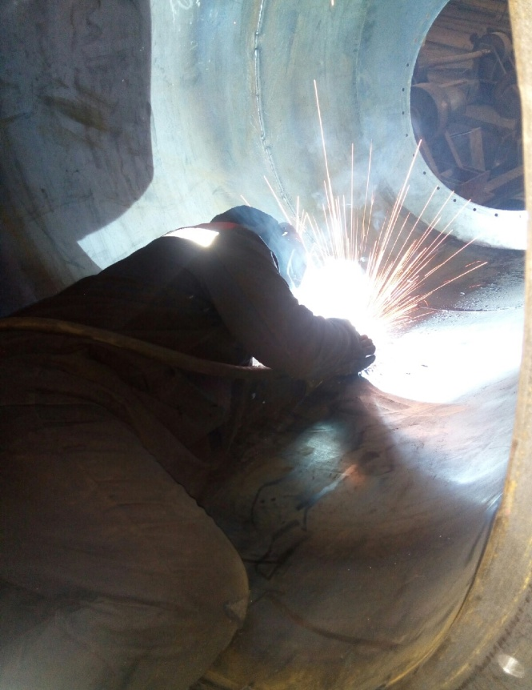Welding is the process of **permanently joining** materials such as various types of metals together. In the **metal inert gas welding** process, electricity travels in an arc from a **welding rod**to a piece — known as a **workpiece** — that is being welded. The current melts a **filler metal** and a portion of the workpiece, which creates a pool of **molten metal**. A permanent weld is produced when this pool is allowed to completely cool. Many methods of welding employ shielding gases such as **argon**, which surround the **electric current** as it streams over from welding rod to workpiece.

Welding engineers are expected to carry out many activities while on duty. Aside from staying on top of his or her regular work activities, a welding engineer is expected to keep up-to-date with the latest welding concepts, technology, and techniques. These engineers are often in charge of monitoring processes and materials to detect problems that may arise in the future. They also are usually in charge of performing regular maintenance and inspections on welding equipment and materials.

Welding engineers may develop new welding application, procedures, and techniques to **fabricate metals** more efficiently. They may work with other personnel and people from outside agencies to exchange ideas and advice. A welding engineer may also be involved in researching and investigating old and new welding equipment to gain insight into possible technological advancements. These engineers are often employed to establish procedures that a company's welding personnel can follow.

The welding process involves a lot of math and dealing with numbers. Welding engineers should be knowledgeable on certain subjects such as algebra, arithmetic, geometry and calculus. A welding engineer must undergo extensive training in a number of subjects, including physics, electricity, **photonics**, **welding systems**, and chemistry. They are exposed to the many different types welding processes and materials joining processes.

The process of **welding materials** can be very dangerous. Most welding engineers have undergone extensive safety training to promote a safe work environment. They handle devices that conduct powerful currents of electricity and much work with potentially dangerous **shielding gases**. These engineers must possess a thorough understanding of how to properly operate such devices to help maintain a safe work environment.

**While-reading activity:**

**I. Answer the following questions on the text.**

1. What responsibilities have welding engineers got? 2. What are main duties of welders? 3. What is welding? 4. How can you describe the metal inert gas welding? 5. How can you describe an up-to-date engineer? 6. What subjects should welders know?

**II. True or false.**

1. Welding is the most common way of permanently joining metal parts.

2. The current melts a filler metal and a portion of the workpiece.

3. Welders don’t use many types of welding equipment set up in a variety of positions.

4. A welding engineer doesn’t have to keep up-to-date with the latest welding concepts, technology, and techniques.

5. Welding engineers are usually in charge of performing regular maintenance and inspections on welding equipment and materials.

6. A welding engineer may also be involved in researching and investigating old and new welding equipment.

7. Welding engineers have to be knowledgeable on certain subjects such as physics and chemistry.

8. A welding engineer isn’t exposed to the many different types welding processes and materials joining processes.

9. The process of welding materials can’t be very [hazardous](https://wooordhunt.ru/word/hazardous).

10. Most welding engineers have undergone extensive safety training to promote a safe work environment.

**After-reading activity**

**I. Make up a summary of the text using the following sentences as a**

**beginning.**

1. The responsibilities of welders … . 2. Welding is…. 3. In the welding process … 4. There are many kinds… 5. Welding engineers are expected … 6. Welders are in charge of … 7. Welding engineers may … 8. Welders are employed in … . 9. Welding engineers should know … . 10. The process of welding can be … .

## 

## Text 2. What Is Welding and What Do Welders Do

**Vocabulary**

**technique** - 1) техника, способ, технические приемы 2) метод; методика,

**case study** - учебный пример; разбор конкретного случая

**shielded metal arc welding** - дуговая сварка покрытым металлическим электродом

**arc welding** - электродуговая сварка

**submerged arc welding** - дуговая сварка под флюсом

**oxyfuel** - газоплазменный

**electric resistance welding** - (контактная) сварка сопротивлением

**tensile test** - испытание на растяжение

**bending test** - испытание на изгиб

**impact test** - испытание на ударную вязкость

**discontinuity** - отсутствие непрерывности, нарушение последовательности

**volumetric** - объемный

**hardness** - твердость, прочность; сопротивляемость (механическим воздействиям)

**tension** - натяжение; растяжение, растягивание, удлинение

**site welding** - монтажные сварочные работы

**heat flow** - тепловой поток

**heat treatment** - термическая обработка

**welding metallurgy** - металлургия сварки

**hardenability** - 1) закаливаемость 2) прокаливаемость 3) способность к закаливанию

**weldability** - свариваемость

**non-ferrous** - цветной (о металле), не содержащий железа

**filler metal** - присадочный металл

**alloy**- сплав

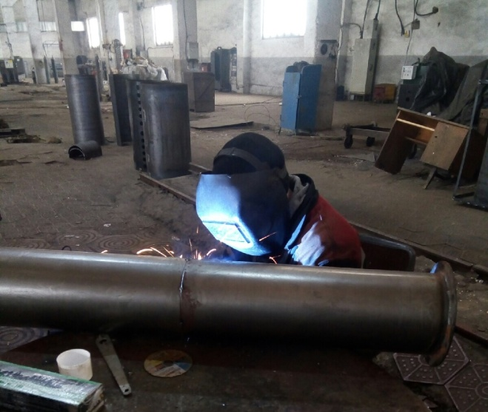Welding is the most economical and efficient way to join metals permanently. It is the only way of joining two or more pieces of metal to make them act as a single piece. Welding is vital to our economy. Welding ranks high among industrial processes and involves more sciences and variables than those involved in any other industrial process. There are many ways to make a weld and many different kinds of welds. Some processes cause sparks and others do not even require extra heat. Welding can be done anywhere… outdoors or indoors, underwater and in outer space.

Nearly everything we use in our daily life is welded or made by equipment that is welded. Welders help build metal products from coffeepots to skyscrapers. They help build space vehicles and millions of other products ranging from oil drilling rigs to automobiles. In construction, welders are virtually rebuilding the world, extending subways, building bridges, and helping to improve the environment by building pollution control devices. The use of welding is practically unlimited. There is no lack of variety of the type of work that is done.

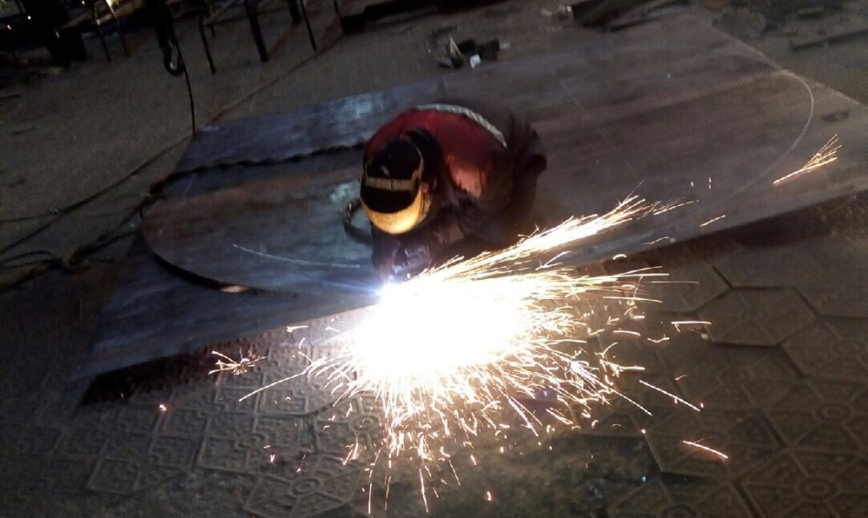Welders are employed in many industry groups. Machinery manufacturers are responsible for agricultural, construction, and mining machinery. They are also involved in bulldozers, cranes, material handling equipment, food-processing machinery, papermaking and printing equipment, textiles, and office machinery.

The fabricated metals products compiles another group including manufacturers of pressure vessels, heat exchangers, tanks, sheet metal, prefabricated metal buildings and architectural and ornamental work. Transportation is divided into two major groups: manufacturers of transportation equipment except motor vehicles; and motor vehicles and equipment. The first includes shipbuilding, aircraft, spacecraft, and railroads. The second includes automobiles, trucks, buses, trailers, and associated equipment.

A Welder permanently joins pieces of metal with metal filler, using heat and/or pressure. Welders join parts being manufactured, they build structures and repair broken or cracked parts, according to specifications.

**Job Related Skills, Interests and Values**

• using and maintaining tools, material handling equipment and welding equipment;

• reading and interpreting blueprints;

• acquiring thorough knowledge of arc, gas and resistance weldingtheory ;

• laying out, cutting and forming metals to specifications;

• preparing the work site.

• fitting sub-assemblies and assemblies together and preparing assemblies for welding ;

• welding using shielded metal arc welding, gas metal arc welding, gas tungsten arc welding, flux core or metal core arc welding, submerged arc welding and plasma arc welding processes;

• carrying out special processes such as welding studs and brazing;

• ensuring quality of product/process before, during and after welding;

**What’s Your Future as a Welder?**

Most workers in this occupation work full-time, sometimes in shift work, usually indoors. Those with the ability to work with high-technology welding applications may have better employment opportunities. The bulk of employment opportunities are predicted to occur in the non-electrical, machinery, construction and metal-fabricating industries. Some workers will become self-employed. Examples of companies that employ welders include:

• Fabricating shops;

• Manufacturers of structural steel and platework;

• Construction industries;

• Boilers;

• Heavy machinery contractors;

• Aircraft contractors;

• Ship building and other transportation contractors;

• Specialized welding shops.

**While-reading activity**

**I. Find the English equivalents for the following words and word combinations.**

Постоянное соединение металлов, сварной шов, промышленные процессы, металлические изделия, теплообменник, резервуар, сборные металлические конструкции, котлы, высокотехнологичный, пайка, контактная сварка.

**II. True or false.**

1. Welding is an important and necessary process in our life. 2. There are other ways to join metals.3. There are many ways to make a weld.4. Welding can be done only indoors.5. Welding is used everywhere.6. The use of welding is practically unlimited.7. Welders are employed in a single industry group.8. Welders can only join pieces of metal. They can repair nothing.9. Welders mustn’t prepare the work site.10. Welders have many opportunities.

**After-reading activity**

**I. Match the words from the list below with their definitions.**

a) alloy, b) joint, c) inspection, d) welding, e) laser, f) design, g) property, h) course, j) plasma, k) arc.

1. To contrive, to formulate, to project, to draw, to plan, to sketch out;

2. Joining pieces of metal (or nonmetal) at faces rendered plastic or liquid by heat or pressure (or both).

3. a) A junction or mode of joining parts together; b) the place where two things are joined together.

4. The luminous arc or bridge across a gap between two electrodes when an electric current is sent through them.

5. a) A careful, narrow or critical examination or survey; b) an official examination.

6. An instrument which amplifies light waves by stimulation to produce a powerful, coherent beam of monochromatic light, an optical maser.

7. Metal blended with some other metallic or nonmetallic substance to give it special qualities, such as resistance to corrosion, greater hardness, or tensile strength.

8. A planned programme of study.

9. Peculiar or inherent quality.

10. A hot, ionized gas containing approximately equal numbers of positive ions and electrons.

**II. Summary the information about welding and welders. Follow the plan:**

* **Welding processes;**
* **Duties of welders;**
* **Welders can do;**
* **Welding is used;**
* **Welders can work at.**

## Part 2. Welding Processes

## 

## Text 1. Introduction to Welding Processes & Equipment

**Vocabulary**

**soldering** - пайка; пайка мягким (легкоплавким) припоем

**tinning** - лужение; облуживание

**leading** - свинцевание

**brazing** - 1) пайка твердым припоем (из меди и цинка) 2) покрытие медью

**sweat** - паять, запаивать, припаивать (in, on)

**gimmick** - сложное приспособление

**filler metal** - присадочный металл

**filler rod** - присадочный пруток; присадочная проволока

**heat buildup** - теплообразование, тепловведение

**heat distortion** – деформация (материала) из-за теплового нагрева

**stitch welding** - прерывистая шовная сварка; точечная сварка перекрывающимися точками; автоматическая точечная сварка

**torch** – горелка

**shield** - экран; щит; предохранительный кожух, защита

Among the first things a new welder needs to understand, is what the different kinds of welding processes and equipment are, and their application.

A quick rundown:

**Terms:**

**Soldering:** Bonding by melting a soft metal to the surface of pieces to be joined. Low temperature. Good for joining dissimilar materials. Most common solders are lead-tin alloys.

**Tinning:** A soldering process, where the surface of a metal is coated with solder.

**Leading:** A form of soldering, solder is used to fill in the surface of metal.

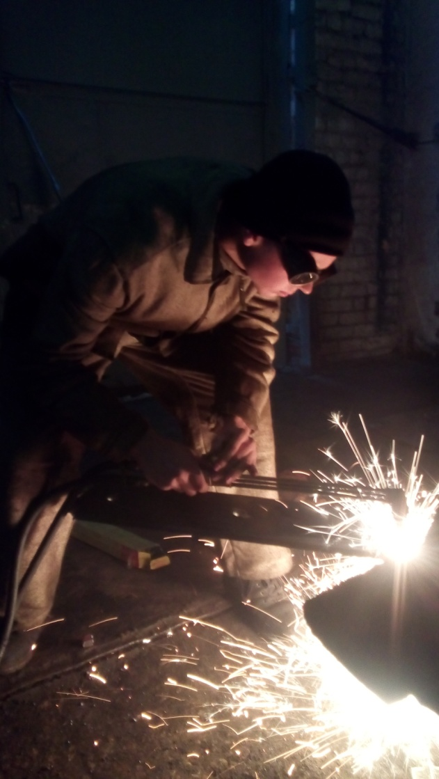**Brazing:** Similar to soldering, but uses a higher temperature to fuse the filler metal to the work pieces. Stronger bond. (Includes "Silver Soldering") Work heated to pre-melt temperatures.

**Welding:** Joining 2 similar work pieces by melting them together, usually with an additional filler rod of some sort to take up space. Materials must be similar.

**Cutting:** Work is heated to melting point and beyond, and "cut" by oxidizing metal.

**Shield:** A barrier to keep oxygen away from heated work to prevent oxidation. Includes chemical coatings called **flux** (liquids, pastes, solids, which may be vaporized into a barrier gas when heated), and inert gasses. Oxidation of the surfaces will prevent proper bonding of the metals.

**Gas Welding:** Uses Flame from burning gas to create welding heat.

**Propane torch:** (*Soldering, heating)* Good for sweating pipes, starting fires, and spending hours trying to heat frozen bolts, while the surrounding metal gets just as hot.

**Oxyacetylene torch:** (*Cutting, welding, brazing, soldering, leading)* Most universal and useful welding tool. (Uses Acetylene gas and Oxygen for hot flame). With the right bits, rod, and technique, you can weld almost anything. Good for cutting anything from sheet metal to the turret off a tank, lead filling, brazing (a sort of hard soldering process) welding plate, welding sheet metal, welding aluminium, heating frozen bolts, or alternately cutting them off, drilling holes in plate, welding cast iron, shrinking and forming steel, and can double as a flame thrower in a pinch. Drawbacks are: Overheating of some types of work, harder to control quality of some processes.

**Oxy-propane:** (*Soldering, brazing, heating)* A cheap compromise between low cost and portable propane, and Oxy-Acetylene. Better than the former, not as good as the latter.

**Arc welding:** Uses an electric arc to create welding heat.

**Basic AC & DC arc welders** (AC is cheaper) Uses flux coated steel (or other) rods of various types for different jobs. Makes some of the best welds on heavy gauge steels and cast iron. Cutting rods can make clean holes through thick stock, and are about the only thing which can cut Kryptonite bike locks. Very difficult to weld thin metals. You can also get a **carbon arc** **torch** to use on an arc welder to braze. Eastwood's **"stitch" welder** is a gimmick used on an arc welder to buzz the rod in and out, which may help on thinner stock.

**MIG (Metal Inert Gas):** A DC arc welding process which uses filler metal fed in the form of a spool of thin wire, shielded by flow of inert gas (He, Argon) instead of flux used in Arc. Very fast, much easier than Arc Welding, with less **heat buildup**. Very good for sheet metal, due to minimal **heat** **distortion**. Harder to weld thick stock, as welds are weaker due to poorer penetration. The modern choice for steel body work, it can also be used for Aluminium with Argon as the shield gas.

**TIG (Tungsten Inert Gas):** A high frequency AC arc process which uses a tungsten electrode shielded by an inert gas to create a fine, controllable torch. Uses a separate filler rod, as in Oxy-Acetylene welding. Capable of welding very thin metals. About the best process for Aluminium, Stainless steel, and other exotic stuff.

**Resistance welding:** includes **spot welding:** Uses the heat generated by electricity flowing through work to melt and fuse. i.e. - put an electrode on either side of 2 overlapped sheets of steel, turn on power. Metal in between heats up, and melts together. An old favorite for assembling car bodies.

**Plasma Cutters:** Not a welder, but related. A high voltage arc is used to superheat and ionize a stream of air to the "plasma" state. The stream of plasma makes a rapid, clean, narrow cut with minimal heating of the work piece.

**While-reading activity**

**I. Match the words to their meanings.**

|  |  |
| --- | --- |
| Brazing | A group of welding processes in which fusion is produced by heat obtained from resistance to the flow of electric current in a circuit of which the workpiece is a part and by the application of pressure. |
| Tinning | It is initiated by heating the edge or leading face of the steel to the ignition temperature using the pre-heat jets only, then using the separate cutting oxygen valve to release the oxygen from the central jet. |
| Torch | A group of welding processes which produce coalescence of materials by heating them to suitable temperature and by using a filler metal having a liquidus not exceeding 450 °C (842 °F). |
| Resistance welding | It is an operation in which a molecular union between the filler metal and the base metal is achieved. |
| Gas welding | A group of welding processes in which a groove, fillet, lap, or flange joint is bonded by using a nonferrous filler metal having a melting point above 800 °F (427 °C) |
| Cutting | A device used in gas welding for mixing and controlling the flow of gases. |
| Soldering | A process in which the welding heat is obtained from a gas flame. |
| Tungsten Inert Gas | A group of welding processes in which fusion is obtained by heating with an electric arc or arcs, with or without the use of filler metal. |
| Metal Inert Gas | It uses a non-consumable [tungsten](https://en.wikipedia.org/wiki/Tungsten) [electrode](https://en.wikipedia.org/wiki/Electrode) to produce the [weld](https://en.wikipedia.org/wiki/Welding). |
| Arc welding | It uses a consumable electrode, or solid electrical conductor, made of a filler metal wire. |

**After-reading activity**

**I. Answer the following questions.**

1. What is the main difference between soldering and brazing?

2. Where is the solder used?

3. What forms of soldering do you know?

4. What use of the cutting is?

5. What is used by welders to prevent oxidation?

6. What makes soldering advantageous before welding?

7. What makes plasma cutting better than gas cutting?

8. What is the main difference between arc welding and gas welding?

9. What types of torches do you know?

10. What can AC & DC arc welders do?

11. What filler metal is used in Metal Inert Gas?

12. What is the main difference between Metal Inert Gas and Arc Welding?

13. What metals are suitable for Tungsten Inert Gas?

14. What does Resistance welding use?

# 

# Part 3. Shielded Metal Arc Welding

**VOCABULARY**

**SMAW** – shielded metal arc welding – дуговая сварка металлическим

электродом в защитной среде

**consumable electrode** – плавящийся

электрод

**to disintegrate** – разлагаться, рас-

падаться

**to give off** – зд. – выделять

**versatility** – зд. – многофункцио-

нальность

**maintenance** – техническое обслу-

живание

**flux-cored electrode** – фитильный

электрод с флюсом

**to strike the arc** –зажечь дугу

**molten slag** – расплавленный шлак

**stub** – огарок электрода

**industrial fabrication** – промыш-

ленное производство

**to initiate** – вызывать, начинать

**filler metal** – наплавочный металл

**electrode holder** – держатель

электрода

**composition** – состав

**weld spatter** – брызги (металла при

сварке)

**penetration** – глубина проплавления

**high current** – ток большой вели- чины

**arc blow** – уход, сдвиг дуги

**to deflect** –уходить в сторону

**restrain** – зажимать

**residual stress** – остаточное напря-

жение

**arc eye** – ослепление от света дуги,

«сварки нахвататься»

**cornea** – роговица глаза

**retina** – сетчатка (глаза)

**filter glass** - светофильтр

**welding helmet** – маска, шлем

(сварщика)

**particulate matter** – мелкие частицы

**clamp** – зажим

**arc distance / length** – расстояние

/ длина дуги

**fluctuations** – отклонения, колебания

**Pre-reading**

***I. Find the Russian equivalents for the words and word combinations in italics in the text.***

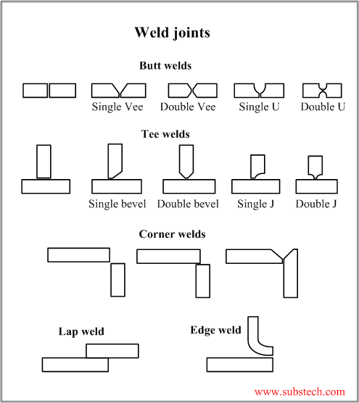Shielded metal arc welding (SMAW), also known as manual **metal arc welding** (MMA) is a manual arc welding process that uses a **consumable electrode** coated in flux to lay the weld. An electric current, in the form of either alternating current or direct current from a welding power supply, is used to form an electric arc between the electrode and the metals to be joined. As the weld is laid, the flux coating of the electrode disintegrates giving off vapors that serve as a shielding gas and providing a layer of slag, both of which protect the weld area from atmospheric **contamination**.

Because of versatility of the process and simplicity of its equipment and operation, shielded metal arc welding is one of the world’s most popular welding processes. It dominates other welding processes in the maintenance and repair industry. And though **flux-covered arc welding** is growing in popularity, SMAW continues to be used extensively in the construction of steel structures and in industrial fabrication. The process is used primarily to weld iron and steels, including stainless steel, but aluminum, nickel and copper alloys can also be welded with this method.

To strike the electric arc the electrode is brought into contact with the workpiece in a short **sweeping motion** and then pulled away slightly. This initiates the arc and thus melting of the workpiece and the consumable electrode, and causes droplets of the electrode to be passed from the electrode to the welding pool. As the electrode melts, the flux disintegrates and its **vapors** protect the weld area from oxygen and other atmospheric gases. In addition, the flux provides molten slag which covers the filler metal as it travels from the electrode to the weld pool. Once part of the weld pool, the slag floats to the surface and protects the weld from contamination as it solidifies. Once hardened, it must be chipped away to reveal the finished weld. As welding progresses and the electrode melts, the welder must periodically stop welding to remove the remaining electrode stub and insert a new electrode into the electrode holder. This activity, combined with chipping away the slag, reduce the amount of time that the welder could spend laying the weld, making SMAW one of the least efficient welding processes. In general, the operator factor, or the percentage of operator’s time spent laying weld, is approximately 25 %.

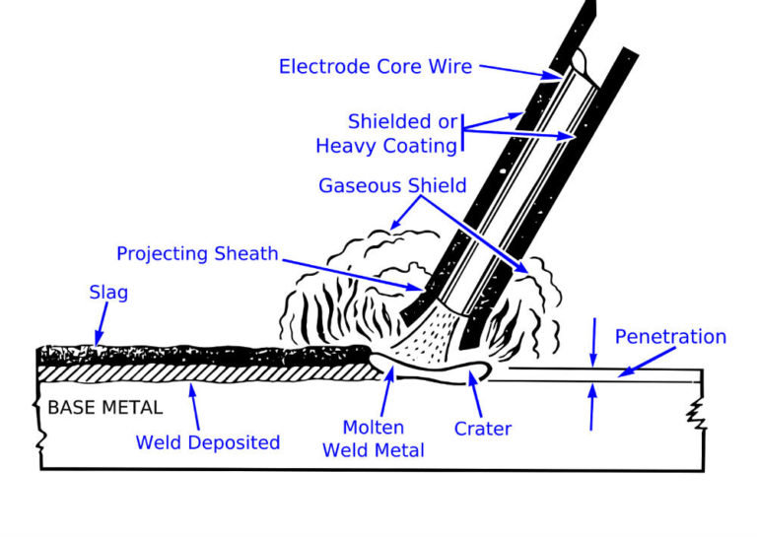The actual welding technique utilized depends on the electrode, the composition of the workpiece, and the position of the joint being welded. The choice of electrode and welding position also determines the welding speed. Flat welds require the least operator skill, and can be done with electrodes that melt quickly but **solidify** slowly. This permits higher welding speeds. Sloped, vertical or upside-down welding requires more operator skill, and often necessitates the use of an electrode that solidifies quickly to prevent the molten metal from flowing out of the weld pool. However, this generally means that the electrode melts less quickly, thus increasing the time required to lay the weld.

The most common quality problems associated with SMAW include **weld spatter**, porosity, **poor fusion**, **shallow penetration** and cracking. Weld spatter, while not affecting the integrity of the weld, damages its appearance and increases

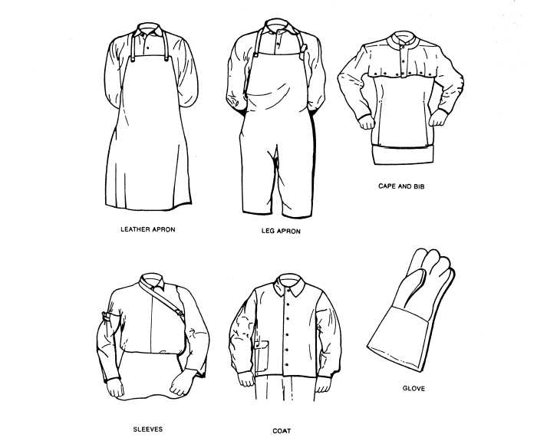cleaning costs. It can be caused by excessively high current, a long arc, or arc blow, a condition associated with direct current characterized by the electric arc being deflected away from the weld pool by magnetic forces. Arc blow can also cause porosity in the weld, as can joint contamination, high welding speed, and a long welding arc, especially when low-hydrogen electrodes are used. Porosity, often not visible without the use of advanced non-destructive testing methods, is a serious concern because it can potentially weaken the weld. Another defect affecting the **strength** of the weld is poor fusion, though it is often easily visible. It is caused by low current, contaminated joint surfaces, or the use of an improper electrode. Shallow penetration, another detriment to weld strength, can be addressed by decreasing welding speed, increasing the current or using a smaller electrode. Any of these weld-strength-related defects can make the weld prone to **cracking**, but other factors are involved as well. High carbon or sulfur content in the base material can lead to cracking, especially if **low-hydrogen electrodes** and preheating are not employed. Furthermore, the workpieces should not be excessively restrained, as this introduces residual stresses into the weld and can cause cracking as the weld cools.

SMA welding, like other welding methods, can be a dangerous and unhealthy practice if proper precautions are not taken. The process uses an open electric arc, presenting a risk of burns which is prevented by personal protective equipment in the form of heavy leather gloves and long sleeve jackets. Additionally, the brightness of the weld area can lead to a condition called *arc eye*, in which ultraviolet light causes the **inflammation** of the cornea and can burn the retinas of the eyes. Welding helmets with dark face plates are worn to prevent this exposure, and in recent years, new helmet models have been produced featuring a face plate that self-darkens upon exposure to high amounts of UV light. To protect by-standers, especially in industrial environments, transparent welding curtains often surround the welding area. These curtains, made of polyvinyl chloride plastic film, shield nearby workers from exposure to the UV light from the electric arc, but should not be used to replace the filter glass used in helmets.

In addition, the **vaporizing metal** and flux materials expose welders to dangerous gases and particulate matter. The smoke produced contains particles of various types of oxides. The size of the particles in question tends to influence the toxicity of the fumes, with smaller particles presenting a greater danger. Additionally, gases like carbon dioxide and ozone can form, which can prove dangerous if ventilation is inadequate.

**After-reading activity**

**I. Complete the sentences using the words.**

*poor fusion slag steel brightness position versatility electrode manual simplicity industrial* *vapors* *composition weld spatter porosity*

1. Shielded metal arc welding (SMAW) is a … arc welding process.

2. An electric current is used to form an electric arc between the … and the metals to be joined.

3. SMAW is one of the world’s most popular welding processes because of … of the process and of … its equipment and operation.

4. SMAW is used extensively in the construction of … structures and in … fabrication.

5. As the electrode melts, the flux disintegrates and its … protect the weld area from oxygen and other atmospheric gases.

6. The flux provides molten … which covers the filler metal.

7. The actual welding technique utilized depends on the electrode, the … of the workpiece, and the … of the joint being welded.

8. … damages the appearance of the weld and increases cleaning costs.

9. … is a serious concern because it can potentially weaken the weld.

10. … is caused by low current, contaminated joint surfaces, or the use of an improper electrode.

11. The … of the weld area can lead to a condition called *arc eye.*

**II. Answer the following questions.**

1. What does SMAW use? 2. Why is the electric current used? 3. Why is SMAW one of the most popular types of welding? 4. Where is SMAW used? 5. What metals are welded with SMAW? 6. How can you describe SMAW? 7. What determines the actual welding technique? 8. What quality problems associated with SMAW do you know? 9. What can cause the weld spatter? 10. What can cause porosity in the weld? 11. What can cause poor fusion? 12. What precautions should welders take? 13. Why is SMAW dangerous?

# 

# Part 4. Gas Metal Arc Welding

**Vocabulary**

**gas metal arc welding (GMAW)** –

дуговая сварка плавящимся элек-

тродом в среде защитного газа

**metal inert gas (MIG) welding** – ду-

говая сварка плавящимся электро-

дом в среде инертного газа

**metal active gas (MAG) welding** –

дуговая сварка плавящимся элек-

тродом в среде активного газа

**welding gun** – сварочный пистолет

**versatility** – многосторонность,

разнообразие

**spot welding** – точечная сварка

**riveting welding** – сварка электро-

заклепками

**resistance spot welding** – контакт-

ная точечная сварка

**robot welding** – сварка с помощью

робота

**dissipation** – рассеяние

**wire feed unit** – устройство для по-

дачи сварочной проволоки

**control switch** – включатель

**contact tip** – контактный конец электрода

**conduit** – желоб

**liner** – выравниватель, направ-

ляющее устройство

**gas hose** – газовый шланг

**buckling** – искривление

**to couple** – соединить

**thermal conductivity** – теплопро-

водность

**anode** – анод

**Pre-reading**

***I. Find the Russian equivalents for the words and word combinations in italics in the text.***

Gas metal arc welding (GMAW), sometimes referred to by its subtypes, **metal inert gas** (MIG) and **metal active gas** (MAG) welding, is a semi-automatic or automatic arc welding process in which a continuous and **consumable wire electrode** and a shielding gas are fed through a welding gun. A constant voltage, direct current power source is most commonly used with GMAW, but constant current systems, as well as alternating current, can be used.

Originally developed for welding aluminum and other **non-ferrous metals** in the 1940s, GMAW was soon applied to steels because it allowed for lower welding time compared to other welding processes. The cost of inert gas limited its use in steels until several years later, when the use of semi-inert gases such as carbon dioxide became common. Further developments during 1950s and 1960s gave the process more **versatility** and as a result, it became a highly used industrial process. Today, GMAW is commonly used in industries such as the automobile industry, where it is preferred for its versatility and speed. Unlike welding processes that do not employ a **shielding gas**, such as shielded metal arc welding, it is rarely used outdoors or in other areas of **air volatility**. A related process, flux-cored arc welding, often does not utilize a shielding gas, instead employing a hollow electrode wire that is filled with flux on the inside.

The method is often used to do **arc spot welding**, thereby replacing riveting or **resistance spot welding**. It is also popular in robot welding, in which robots handle the work-pieces and the welding gun to quicken the manufacturing process. Generally, it is unsuitable for welding outdoors, because the movement of the surrounding atmosphere can cause the dissipation of the shielding gas and thus makes welding more difficult, while also decreasing the quality of the weld, so the use of GMAW in the construction industry is rather limited. The problem can be alleviated to some extent by increasing the shielding gas output, but this can be expensive. The use of a shielding gas makes GMAW an unpopular underwater welding process, and for the same reason it is rarely used in space applications.

To perform gas metal arc welding, the basic necessary equipment is a welding gun, a wire feed unit, a welding power supply, an electrode wire, and a shielding gas supply. The typical welding gun has a number of key parts – a control switch, a **contact tip**, a **power cable**, a **gas nozzle**, an electrode conduit and liner, and a gas hose. The control switch or trigger, when pressed by the operator, initiates the wire feed, electric power and the shielding gas flow, causing an electric arc to be struck. The contact tip, normally made of copper and sometimes chemically treated to reduce **spatter**, is connected to the welding power supply source through the power cable and transmits the electrical energy to the electrode while directing it to the weld area. It must be firmly secured and properly sized since it must allow the passage of the electrode while maintaining an electrical contact. Before arriving at the contact tip, the wire is protected and guided by the electrode conduit and liner, which help prevent buckling and maintain an uninterrupted wire feed. The gas nozzle is used to evenly direct the shielding gas into the welding zone – if the flow is inconsistent, it may not provide adequate protection of the **weld area**. Larger nozzles provide greater shielding gas flow, which is useful for high current welding operations, in which the size of the molten weld pool is increased. The gas is supplied to the nozzle through a gas hose, which is connected to tanks of shielding gas. Sometimes a water hose is also built into the welding gun, cooling the gun in high heat operations.

The wire unit supplies the electrode to the work, driving it through the conduit and on to the contact tip. Most models provide the wire at constant feed rate, but more advanced machines can vary the feed rate in response to the arc length and voltage. Some wire feeders can reach feed rates as high as 30,5 m/min, but feed rates for semi-automatic GMAW typically range from 2 to 10 m/min.

Most applications of gas metal arc welding use a constant voltage power supply. As a result, any change in **arc length**, which is directly related to voltage, results in a large change in **heat input** and current. A shorter arc length will cause a much greater heat input, which will make the wire electrode melt more quickly and thereby restore the original arc length. This helps operators keep the arc length consistent even when manually welding with hand-held welding guns. To achieve a similar effect, sometimes a constant current power source is used in combination with an arc voltage-controlled wire feed unit. In this case, a change in arc length makes the wire feed rate adjust in order to maintain a relatively constant arc length. In rare circumstances, a **constant current** power source and a constant wire feed rate unit might be coupled, especially for the welding of metals with **high thermal conductivity**, such as aluminum. This grants the operator additional control over the heat input into the weld, but requires significant skill to perform successively.

**After-reading activity**

**I. *Find the English equivalents for the words and word combinations in the text.***

Дуговая сварка плавящимся электродом в среде защитного газа; источник постоянного тока; дуговая сварка плавящимся электродом в среде инертного газа; дуговая сварка плавящимся электродом в среде активного газа; двуокись углерода; цветные металлы; полуинертный газ; разнообразие, многосторонность применения; защитный газ; точечная сварка; сварка электрозаклепками; дуговая сварка под флюсом; сварка порошковой проволокой (трубчатым электродом); подключать, соединять; включатель.

**II. Find the synonyms of the words and word combinations in the text.**

to decrease, control switch, welder, to employ a gas, widely, medium ot atmosphere, to start the wire feed, to initiate an arc, metal droplets, wire-feed unit.

**III. True or false.**

1. Gas metal arc welding (GMAW) is sometimes referred to by its subtypes metal inert gas (MIG) and metal active gas (MAG) welding.

2. GMAW was developed for welding aluminum and other non-ferrous metals.

3. GMAW is often used outdoors or in other areas of air volatility.

4. The method is often used to do arc spot welding.

5. GMAW is a popular underwater welding process.

6. The basic necessary equipment is a welding gun, a wire feed unit, a welding power supply, an electrode wire, and a shielding gas supply.

7. The contact tip is normally made of steel.

8. Larger nozzles provide greater shielding gas flow.

9. If the flow is inconsistent, it may not provide adequate protection of the weld area.

10. Most applications of gas metal arc welding use a constant voltage power supply.

# 

# Part 5. Flux-cored Arc Welding

**Pre-reading**

***I. Find the Russian equivalents for the words and word combinations in italics in the text.***

Flux-cored arc welding (FCAW) is a semi-automatic or automatic arc welding process. FCAW requires a continuously fed consumable **tubular electrode** containing a **flux** and **constant voltage** or, less commonly, a **constant electric current** welding power supply. An externally supplied **shielding gas** is sometimes used, but often the flux itself is relied upon to generate the necessary protection from the atmosphere. The process is widely used in construction because of its high **welding speed** and **portability**.

FCAW was first developed in the early 1950s as an alternative to shielded metal arc welding (SMAW). The advantage of FCAW versus SMAW is that the use of stick electrodes, like those used in SMAW, was unnecessary. This helped FCAW to overcome many of the **restrictions** associated with SMAW.

There are two types of FCAW. The first type requires no shielding gas. This is made possible by the flux core in the tubular consumable electrode. However, this core contains more than just flux; it also contains various ingredients that when exposed to high temperatures of welding generate a shielding gas for protecting the arc. This type of FCAW is preferable because it is portable and has excellent **penetration** into the base metal. Also, the conditions of air flow do not need to be considered.

The second type of FCAW actually uses a shielding gas that must be supplied by an **external device**. This type of FCAW was developed primarily for welding steels. In fact, since it uses both a flux-cored electrode and an external shielding gas, one might say that it is a combination of gas metal (GMAW) and flux-cored arc welding. This particular style of FCAW is preferable for welding thicker metals. The slag created by the flux is also easier to remove. However, it cannot be used in a windy environment as the loss of the shielding gas from air flow will produce visible **porosity** on the surface of the weld.

**After-reading activity**

**I. True or false.**

1. Flux-cored arc welding is a semi-automatic or automatic arc welding process.

2. It uses a consumable electrode, or solid electrical conductor, made of a filler metal wire.

3. Flux-cored arc welding is widely used in construction.

4. FCAW was developed as an alternative to gas tungsten arc welding (STAW).

5. There are two types of FCAW.

6. The first type of FCAW uses shielding gas.

7. This type of FCAW is portable and has excellent penetration into the base metal.

8. The second type of FCAW actually uses a shielding gas.

9. The second type of FCAW is preferable for welding thicker metals.

10. The second type of FCAW can be used in a windy environment.

**II. Answer the following questions**

1. What does FCAW use? 2. Where is this process used? 3. When was FCAW developed? 4. What type of welding is similar to FCAW? 5. What is the main difference between FCAW and SMAW? 6. How many types of FCAW do you know? 7. What does the first type of FCAW use? 8. What is the main difference between the types of FCAW?

# Part 6. Gas Tungsten Arc Welding

**VOCABULARY**

**gas tungsten arc welding (GTAW)** – сварка вольфрамовым углеродом в газовой среде

**TIG – tungsten inert gas welding** – сварка вольфрамовым электродом в среде инертного газа

**non-consumable electrode** – неплавящийся электрод

**shielding gas** – защитный газ

**filler metal** – наполнитель

**autogenous** – автогенный

**power supply** – источник тока

**vapors** – пары

**magnesium** – магний

**shielded (metal) arc welding** – дуговая сварка в защитной среде металлическим электродом

**gas metal arc welding** – газовая дуговая сварка металлическим электродом

**dross** – окалина

**bottled gas** – баллонный газ

**heliarc welding** – дуговая сварка в гелиевой среде

**polarity** – полярность

**alternating current** – переменный ток

**water-cooled torches** – водоохлаждаемая горелка

**welding atmosphere** – зд. – защитная среда при сварке

**nozzle** – наконечник, мундштук

**mild steel** – низкоуглеродистая, мягкая сталь

**low alloy** – низколегированный сплав

**martensite** – мартенсит, кристаллизация твердого тела

**ferritic** – ферритный, содержащий

железо

**tapered** – конусообразный

**root side** – основание шва

**fiberglass** – стекловолокно

**heat resistant** – жароупорный, жаростойкий

**dissimilar** – разнородный

**carbon steel** – углеродистая сталь

**cast iron** – чугун

**to coat** – покрывать

**overlaying** – покрытие слоем краски, лака и др.

**gap dimensions** – размеры зазора

**bevel angle** – угол скоса

**pulsed current** – импульсный ток

**weld pool** – зона расплава

Gas tungsten arc welding (GTAW), or tungsten inert gas (TIG) welding, is a manual welding process that uses a nonconsumable electrode made of tungsten, an inert or semi-inert gas mixture, and a separate filler material. Especially useful for welding thin materials, this method is characterized by a stable arc and high quality welds, but it requires significant operator skill and can only be accomplished at relatively low speeds. It can be used on nearly all weldable metals, though it is most often applied to stainless steel and light metals. It is often used when quality welds are extremely important, such as in bicycle, aircraft and naval applications. 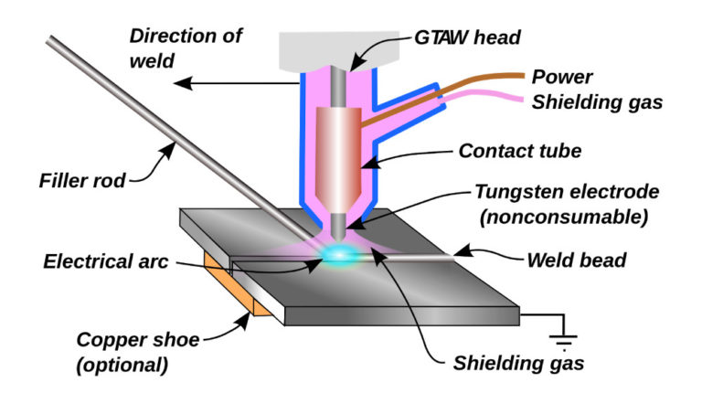A related process, plasma arc welding, also uses a tungsten electrode but uses plasma gas to make the arc. The arc is more concentrated than the GTAW arc, making transverse control more critical and thus generally restricting the technique to a mechanized process. Because of its stable current, the method can be used on a wider range of material thicknesses than can the GTAW process, and furthermore, it is much faster. It can be applied to all of the same materials as GTAW except magnesium, and automated welding of stainless steel is one important application of the process. A variation of the process is plasma cutting, an efficient steel cutting process. Other arc welding processes include atomic hydrogen welding, carbon arc welding, electroslag welding, electrogas welding, and stud arc welding.

**After-reading activity**

**I. Continue the following sentences.**

1. Gas tungsten arc welding (GTAW) is a manual welding process that uses...

2. Gas tungsten arc welding is especially useful for welding ...

3. GTAW can be used on nearly all weldable ...

4. It is often used when quality welds are extremely important, such as in ...

5. Because of its stable current, the method can be used on a wider range of material...

6. It can be applied to all of the ...

7. A variation of the process is ...

**II. Translate the sentences from Russian into English.**

1. Газовая вольфрамовая дуговая сварка - это процесс ручной сварки, в котором используется неплавящийся электрод из вольфрама, смесь инертного или полуинертного газа и отдельный присадочный материал.

2. Газовая вольфрамовая дуговая сварка характеризуется стабильной дугой и высококачественными сварными швами.

3. Газовую вольфрамовую дуговую сварку чаще всего применяют для нержавеющей стали и легких металлов,

4. Плазменная резка - эффективный процесс резки стали.

5. Процессы дуговой сварки включают атомно-водородную сварку, угольную сварку, электрошлаковую сварку, электрогазосварку и дуговую сварку.

# Приложение 1

# 

# Welding Theory & Application Definitions

|  |  |
| --- | --- |
| ARC WELDING | A group of welding processes in which fusion is obtained by heating with an electric arc or arcs, with or without the use of filler metal. |
| ATOMIC HYDROGEN WELDING | An arc welding process in which fusion is obtained by heating with an arc maintained between two metal electrodes in an atmosphere of hydrogen. Pressure and/or filler metal may or may not be used. |
| BACKHAND WELDING | A welding technique in which the flame is directed towards the completed weld. |
| BARE METAL-ARC WELDING | An arc welding process in which fusion is obtained by heating with an unshielded arc between a bare or lightly coated electrode and the work. Pressure is not used and filler metal is obtained from the electrode. |
| BRAZE WELDING | A method of welding by using a filler metal that liquefies above 450°C (842 °F) and below the solid state of the base metals. Unlike brazing, in braze welding, the filler metal is not distributed in the joint by capillary action. |
| CARBON-ARC WELDING | A welding process in which fusion is produced by an arc between a carbon electrode and the work. Pressure and/or filler metal and/or shielding may or may not be used. |
| FLASH WELDING | A resistance welding process in which fusion is produced, simultaneously over the entire area of abutting surfaces, by the heat obtained from resistance to the flow of current between two surfaces and by the application of pressure after heating is substantially completed. Flashing is accompanied by expulsion of metal from the joint. |
| FLOW WELDING | A process in which fusion is produced by heating with molten filler metal poured over the surfaces to be welded until the welding temperature is attained and the required filler metal has been added. The filler metal is not distributed in the joint by capillary attraction. |
| FOREHAND WELDING | A gas welding technique in which the flare is directed against the base metal ahead of the completed weld. |
| FORGE WELDING | A group of welding processes in which fusion is produced by heating in a forge or furnace and applying pressure or blows. |
| GAS CARBON-ARC WELDING | An arc welding process in which fusion is produced by heating with an electric arc between a carbon electrode and the work. Shielding is obtained from an inert gas such as helium or argon. Pressure and/or  filler metal may or may not be used. |
| GAS METAL-ARC (MIG) WELDING (GMAW) | An arc welding process in which fusion is produced by heating with an electric arc between a metal electrode and the work. Shielding is obtained from an inert gas such as helium or argon. Pressure and/or  filler metal may or may not be used. |
| GAS TUNGSTEN-ARC (TIG) WELDING (GTAW) | An arc welding process in which fusion is produced by heating with an electric arc between a tungsten electrode and the work while an inert gas forms around the weld area to prevent oxidation. No flux is used. |
| GAS WELDING | A process in which the welding heat is obtained from a gas flame. |
| IMPREGNATED-TAPE METAL-ARC WELDING | An arc welding process in which fusion is produced by heating with an electric arc between a metal electrode and the work. Shielding is obtained from decomposition of impregnated tape wrapped around the electrode as it is fed to the arc. Pressure is not used, and filler metal is obtained from the electrode. |
| INDUCTION WELDING | A process in which fusion is produced by heat obtained from resistance of the work to the flow of induced electric current, with or without the application of pressure. |
| METAL-ARC WELDING | An arc welding process in which a metal electrode is held so that the heat of the arc fuses both the electrode and the work to form a weld. |
| OXYACETYLENE WELDING | A welding process in which the required temperature is attained by flames obtained from the combustion of acetylene with oxygen. |
| OXY-HYDROGEN WELDING | A gas welding process in which the required welding temperature is attained by flames obtained from the combustion of hydrogen with oxygen. |
| PERCUSSIVE WELDING | A resistance welding process in which a discharge of electrical energy and the application of high pressure occurs simultaneously, or with the electrical discharge occurring slightly before the application of  pressure. |
| RESISTANCE WELDING | A group of welding processes in which fusion is produced by heat obtained from resistance to the flow of electric current in a circuit of which the workpiece is a part and by the application of pressure. |
| SHIELDED WELDING | An arc welding process in which protection from the atmosphere is obtained through use of a flux, decomposition of the electrode covering, or an inert gas. |
| SUBMERGED ARC WELDING | An arc welding process in which fusion is produced by heating with an electric arc or arcs between a bare metal electrode or electrodes and the work. The welding is shield by a blanket of granular, fusible material on the work. Pressure is not used. Filler metal is obtained from the electrode, and sometimes from a supplementary welding rod. |

# Приложение 2

# 

# Англо-русский словарь сварщика

**alloy**- сплав

**alternating current** – переменный ток

**atomic hydrogen welding –** атомно-водородная сварка

**anode** – анод

**arc blow** – уход, сдвиг дуги

**arc distance / length** – расстояние / длина дуги

**arc eye** – ослепление от света дуги, «сварки нахвататься»

**arc welding** - электродуговая сварка

**arc welding alternator** - генератор переменного тока для дуговой сварки

**arc-welding head -** головка для дуговой сварки

**autogenous** – автогенный

**backhand welding** -[cварка обратным способом](https://dic.academic.ru/dic.nsf/metallurgy/308/%D0%A1%D0%B2%D0%B0%D1%80%D0%BA%D0%B0)

**bare metal-arc welding** - дуговая сварка голым электродом

**bending test** - испытание на изгиб

**bevel angle** – угол скоса

**bottled gas** – баллонный газ

**braze welding -** cварка с припоем

**brazing** - 1) пайка твердым припоем (из меди и цинка) 2) покрытие медью

**bridge welding -**сварка встык с накладкой

**buckling** – искривление

**butt-seam welding-** шовно-стыковая сварка

**carbon steel** – углеродистая сталь

**cast iron** – чугун

**clamp** – зажим

**coat** – покрывать

**consumable electrode** – плавящийся электрод

**contact tip** – контактный конец электрода

**control switch** – включатель

**deflect** –уходить в сторону

**disintegrate** – разлагаться, распадаться

**disk welding**- сварка с прокладкой дисков

**dissimilar** – разнородный

**dissipation** – рассеяние

**dross** – окалина

**electric resistance welding** - (контактная) сварка сопротивлением

**electrode holder** – держатель электрода

**ferritic** – ферритный, содержащий железо

**fiberglass** – стекловолокно

**filler metal** - присадочный металл

**filler rod** - присадочный пруток; присадочная проволока

**filter glass** - светофильтр

**flash welding -** [cтыковая сварка оплавлением](https://dic.academic.ru/dic.nsf/metallurgy/2237/%D0%A1%D1%82%D1%8B%D0%BA%D0%BE%D0%B2%D0%B0%D1%8F)

**flow welding -** [сварка](https://dic.academic.ru/dic.nsf/metallurgy/2289/%D0%A1%D0%B2%D0%B0%D1%80%D0%BA%D0%B0) потоком

**fluctuations** – отклонения, колебания

**flux-cored electrode** – фитильный электрод с флюсом

**forehand**[**welding**](https://wooordhunt.ru/word/welding) **-**сварка левым способом, левая сварка

**forge welding–**кузнечная сварка

**gas carbon-arc welding** дуговая сварка угольным электродом в среде

защитного газа

**gap dimensions** – размеры зазора

**gas hose** – газовый шланг

**gas metal arc welding (GMAW)** – дуговая сварка плавящимся электродом в среде защитного газа

**gas tungsten arc welding (GTAW)** – сварка вольфрамовым углеродом в газовой среде

**gas welding –**газовая сварка

**gimmick** - сложное приспособление

**hardenability** - 1) закаливаемость 2) прокаливаемость 3) способность к закаливанию

**hardness** - твердость, прочность; сопротивляемость (механическим воздействиям)

**heat buildup** - теплообразование, тепловведение

**heat distortion** – деформация (материала) из-за теплового нагрева

**heat flow** - тепловой поток

**heat resistant** – жароупорный, жаростойкий

**heat treatment** - термическая обработка

**heliarc welding** – дуговая сварка в гелиевой среде

**high current** – ток большой величины

**impact test** - испытание на ударную вязкость

**induction welding -** индукционная сварка

**intermittent welding**-прерывистая сварка

**leading** - свинцевание

**liner** – выравниватель, направляющее устройство

**low alloy** – низколегированный сплав

**machine welding**- механизированная сварка

**magnesium** – магний

**maintenance** – техническое обслуживание

**martensite** – мартенсит, кристаллизация твердого тела

**metal active gas (MAG) welding** – дуговая сварка плавящимся электродом в среде активного газа

**metal arc welding –** дуговая сварка металлическим электродом

**metal inert gas (MIG) welding** – дуговая сварка плавящимся электродом в среде инертного газа

**mild steel** – низкоуглеродистая, мягкая сталь

**molten slag** – расплавленный шлак

**non-consumable electrode** – неплавящийся электрод

**non-ferrous** - цветной (о металле), не содержащий железа

**nozzle** – наконечник, мундштук

**overlaying** – покрытие слоем краски, лака и др.

**oxyacetylene welding -** ацетиленокислородная сварка

**oxyfuel** - газоплазменный

**oxyhydrogen welding -** кислородно-водородная сварка

**particulate matter** – мелкие частицы

**penetration** – глубина проплавления

**percussion welding -**ударная сварка

**polarity** – полярность

**power supply** – источник тока

**pulsed current** – импульсный ток

**residual stress** – остаточное напряжение

**resistance spot welding** – контактная точечная сварка

**resistance welding** – контактная сварка

**restrain** – зажимать

**riveting welding** – сварка электрозаклепками

**robot welding** – сварка с помощью робота

**root side** – основание шва

**site welding** - монтажные сварочные работы

**shield** - экран; щит; предохранительный кожух, защита

**shielded metal arc welding** (**SMAW**) - дуговая сварка металлическим электродом в защитной среде

**shielding gas** – защитный газ

**soldering** - пайка; пайка мягким (легкоплавким) припоем

**spot welding** – точечная сварка

**stitch welding** - прерывистая шовная сварка; точечная сварка перекрывающимися точками; автоматическая точечная сварка

**strike the arc** –зажечь дугу

**stub** – огарок электрода

**submerged arc welding** - дуговая сварка под флюсом

**sweat** - паять, запаивать, припаивать (in, on)

**tapered** – конусообразный

**technique** - 1) техника, способ, технические приемы 2) метод; методика

**tensile test** - испытание на растяжение

**tension** - натяжение; растяжение, растягивание, удлинение

**tinning** - лужение; облуживание

**thermal conductivity** – теплопроводность

**torch** – горелка

**tungsten inert gas welding – TIG** – сварка вольфрамовым электродом в среде инертного газа

**vapors** – пары

**versatility** – многосторонность, разнообразие, многофункциональность

**volumetric** - объемный

**water-cooled torches** – водоохлаждаемая горелка

**weld pool** – зона расплава

**weld spatter** – брызги (металла при сварке)

**weldability** - свариваемость

**welding atmosphere** – зд. – защитная среда при сварке

**welding gun** – сварочный пистолет

**welding helmet** – маска, шлем (сварщика)

**welding metallurgy** - металлургия сварки

**wire feed unit** – устройство для подачи сварочной проволоки

# Список литературы

1. Агабекян, И.П. Английский для технических вузов [Текст] / И.П. Агабекян. – Ростов н/Д: Феникс, 2001. – 352 с.

2. Золотых, В.Т. Англо-русский словарь по сварочному производству [Текст] / В.Т. Золотых. – М.: Главная редакция иностранных научно-технических словарей ФИЗМАТГИЗА, 1961. – 192 с.

3. Хромченко, Ф.А. Сварочное пособие электросварщика [Текст] / Ф.А. Хромченко. – М.: Машиностроение, 2003. – 420 с.

4. Welding [Электронный ресурс]. – Режим доступа : http://solowelding.com/welding/ (дата обращения 23.03.2019).

5. What does a welding engineer do? [Электронный ресурс]. – Режим доступа : https://www.wisegeek.com/what-does-a-welding-engineer-do.htm (дата обращения 11.03.2019).