1. ИНФОРМАЦИЯ О РАЗРАБОТЧИКЕ ПЛАНА
ФИО разработчика | Притыка Ирина Валентиновна
Место работы | МУНИЦИПАЛЬНОЕ КАЗЕННОЕ ОБЩЕОБРАЗОВАТЕЛЬНОЕ УЧРЕЖДЕНИЕ ОБЩЕОБРАЗОВАТЕЛЬНАЯ ШКОЛА № 24 г. РОССОШИ
2. ОБЩАЯ ИНФОРМАЦИЯ ПО УРОКУ
Класс (укажите класс, к которому относится урок): | 5
Место урока (по тематическому планированию ПРП) | № 41, 12.12.2025
Тема урока | Школа, школьная жизнь (школьные предметы) Мой любимый предмет.
Уровень изучения (укажите один или оба уровня изучения (базовый, углубленный), на которые рассчитан урок): | БАЗОВЫЙ
Тип урока (укажите тип урока): | Комбинирований
Планируемые результаты (по ПРП):
Личностные
Формирование мотивации к продолжению изучения английского языка; развитие стремления к самосовершенствованию в данной предметной области.
Развитие навыков коллективной учебной деятельности, умения работать в паре (группе); установление дружеских взаимоотношений в коллективе, основанных на взаимопомощи и взаимной поддержке.
Формирование навыков самоанализа и самоконтроля.
Метапредметные
Коммуникативные: Адекватно использовать речевые средства для решения различных коммуникативных задач.
Читать текст с целью поиска конкретной информации. Понимать английскую речь на слух с целью извлечения конкретной информации.
Регулятивные. Развивать мотивы и интересы познавательной деятельности.
Учитывать выделенные учителем ориентиры действия в новом учебном материале в сотрудничестве с педагогом и самостоятельно. Самостоятельно ставить цели, планировать пути их достижения, выбирать наиболее эффективные способы решения учебных и познавательных задач.
Познавательные. Использовать знаково-символические средства представления информации для решения учебных задач. Выделять и фиксировать нужную информацию в тексте.
Предметные
Уметь называть школьные принадлежности, учебные предметы, дни недели.
Овладевать навыками чтения и аудирования.
Ключевые слова school subjects: English, Math, Science, History, Art, Geography, Music, Information Technology, Physical Educational; timetable; days of week
Краткое описание Учебник Spotlight 5 кл., «Просвещение», 2023 г.; рабочая тетрадь, тетрадь – словарик, audioskazki-online.ru, карточки с заданиями

Этап урока | Действия учителя | Действия учеников | Материалы
Organisational moment. Inclusion in educational activities.  A brief discution:  II Updating previously learned material  2)Speech warm up:  III Learning material  Tecnology  “Fishbone”  Introduction of new words and expression related to the learning process and favorite subjects.  Grammar unit: Modal Verbs- can and must | Good morning, dear pupils and guests! I’m very glad to see you. Let’s check, who is absent today?  Who is on duty today?  What`s date today?  What`s day of the week?  What is the weather like?  Do you like school? What subject do you have today? What do students do at school?  How do students behave? (duties)  What are we going to learn today? What is our goal for today?  Let’s put it down!  Технология «Fish bone»  Discuss school subjects that have already been studied: Math, English, Histoty, Geography, PE, Music, Art.  What is you favourite subject?  What subject do you have on Monday?  Do you like PE? What do you do on PE?  What should we know ?  Should we know the names of the subjects?  Let’s say, what is object?  What furniture do classes have?  Ok, these are the features of school and school life  . Let’s write them.  Vocabulary  Homework, lesson, test, exam, classroom, blackboard, schoolbag, timetable.  Verbs: study, learn, teach, do homework, take a test, pass an exam,  Each day of the week has a timetable  Let’s have a look at the slide  Explanation of use of model verbs can and must in the context of school life.  Can is used to express of possibility:  I can speak English.  You can play sports after school  Must is used to express commitment:  We must do our homework every day.  I must study my test.  I must go to school evry day.  We can learn new things at school. | Ss answer  I`m on duty today. The 12th of December. It`s Friday.  Ss Yes, I do.Math, English, PE, Literature,  Have lessons, meet friends, have brakes. Look and Listen.  Ss say, that they should write a letter to the employer to become this position.  Ss Maths, Russian,Literature, HistoryS My Favourite subject is…  I like PE. We run, jump, do exercises.  Students make sentences with new vocabulary:  I like History. It is my favourite subject.  I have English lessons on Mondays.  I do my homework after school.  Students make sentences using can and must:  I can play baskeball after school.  We must listen to our teacher. | Презентация, 2 слайд  Cлайды 2  Слайд 5  Слайд 6  Слайд 7(открывать по мере ответов учеников)  Слайды 8,9
Listening:  Reading  After reading task:  VI Reinforcement of the material (game)  Discution of the game results:  V Lesson summery and reflection | Ex. 4 page 30  What can Peter do at this school?  What should he do in the school?  “School Interview”  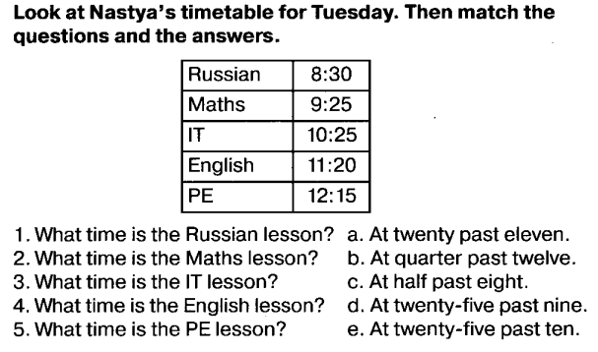  What must we always do in school? What can we do after lessons?  What did we learn today?  What new words did you learn?  Thank you everyone. You did a great job today! | Students listen to the audio recoding and choose the correct option.  Students read a text about the school life of one school, who tells them what thy can and should do at school.  Students work in pairs. One student plays the role of journalist, and the other student. The journalist asks questions about school life, opportunities, and responsibilities.  Examples of questions:  Can you play sports in your school?  What must you do before the test?  What can you do after the lesson?  Each student must tell us about themselves using can and must:  I must study for my test. I can play football after school. I must must do my homework before I go out. I can speak two languages.  Have lessons, meet friends, have brakes. Look and Listen
Homework assignment | Write 5 sentences with can and must (on the topic “School”)
7) Рефлексия (подведение итогов занятия) | What have we learnt today? Was it usefull for you?

