**Работа с грамматическим материалом Present Continuous**

**5 класс, учебник «Enjoy English»**

**Presentation**

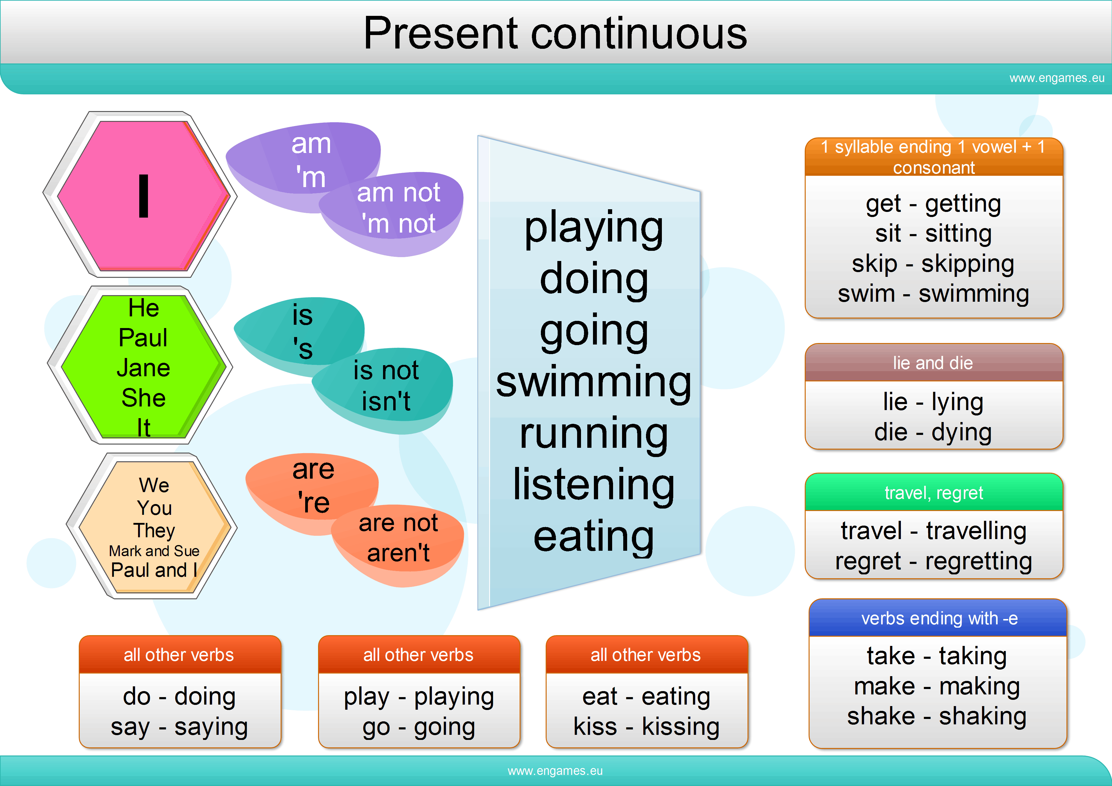

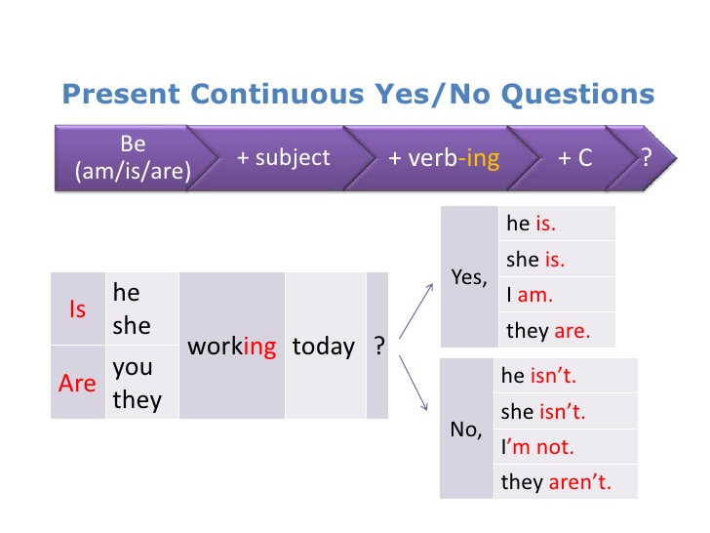

**Practice**

**1**

**Go to the blackboard and write the ing-forms to the following verbs:**

*smile, visit, make, write, play, shake, use, run, swim, put, work, cut, get, take, chat, talk, have, ride, travel*

**2**

**Translate the sentences from Russian into English, using Present Continuous:**

Я улыбаюсь. Она пишет. Он играет. Мы бегаем. Они плавают. Они разговаривают. Вы путешествуете.

**3**

**Look at the pictures and make up sentences, using Present Continuous:**

watch TV, play with pet, sleep, sing, celebrate birthday, do sport, water the flowers, speak on the phone, make a cake, dance, ride a bike, take a picture

|  |  |  |  |
| --- | --- | --- | --- |
|  |  |  |  |
|  |  |  |  |
|  |  |  |  |

**4**

**Work in pairs. Complete each sentence with the Present Continuous of the verbs in brackets.** (после выполнения задания учащиеся обмениваются работами и проверяют друг друга, правильные ответы учитель выписывает на доску или выводит на экран)

1. My pet ……..(u, n, r) now.
2. Jane's brother ….(i, s, m, w) now.
3. I …..(i,t,s) on the sofa.
4. The children ….(y,a,l,p) board games now.
5. Bill's brothers …..(e,k,a,m) a model of a plane now.
6. My friends ….(a,e,s,k,t) now.
7. I …..(e,i,r,w,t) now.
8. Mary and Susan ….(a,a,e,t,r,s,n,t,l) a text now.
9. The teacher ….(a,k,s) the questions now.
10. The pupils …..(isdscus) the film now.

**5**

**Answer my questions, please:**

**What is the weather like today?** Is the sun shining? Is the wind blowing? Are the yellow leaves falling on the ground? Is it snowing? Is it getting colder?

**What are you doing now?** Are you having the English lesson? Are you sitting? Are you standing? Are you listening to the teacher? Are you doing different exercises? Are you singing? Are you reading? Are you writing? Are you learning grammar? Are you learning new words? What are you wearing today?

**6**

Учащиеся получают карточки с разными глаголами: *jump, run, swim, read, write, draw, count, clean the blackboard, open the door, play the piano, cook, listen to music, eat, drink, smile, wash up*. Каждый учащийся должен выйти к доске и изобразить действие. Остальные ребята угадывают и строят вопросительные и утвердительные предложения.

Pupil 1: What is she/ he doing? Pupil 2: She is counting.

**7**

**Work in pairs. Correct the mistakes** (после выполнения задания учащиеся обмениваются работами и проверяют друг друга, видя правильные ответы на доске или на экране)

1. John drives a kart now.
2. We are visit our grandparents now.
3. We not going to school today.
4. At the moment Peter is work in the garden.
5. We are have a good time.
6. What you doing now?
7. Kate's parents watch a television programme now.
8. It rains very hard at the moment.
9. Listen. The telephone is ring now.
10. Look at Tom. He is ride a horse.

**Production**

**8**

**Open your textbook on page 67 and describe the picture, using Present Continuous.**

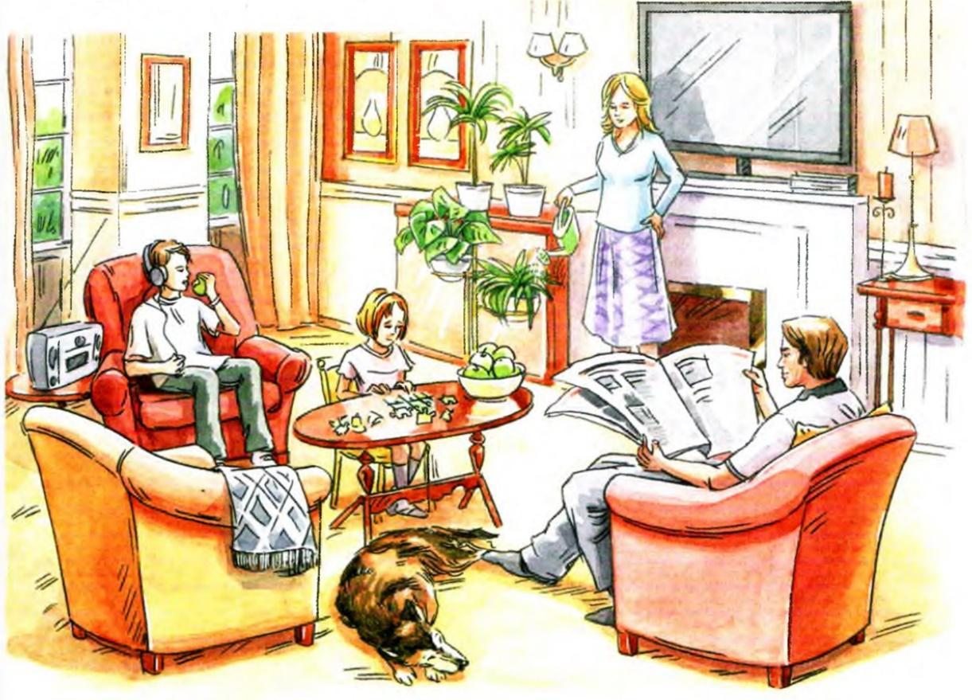

**9**

**Work in pairs. Make up the dialogues**. **Use the verbs in Present continuous.**

Учащиеся составляют небольшие диалоги, например:

* Where is Sandra?
* She is in the kitchen.
* What is she doing there? Is she reading a newspaper?
* No, she isn’t. She is cooking dinner.

**10**

**Домашнее задание: описать картинку, используя Present Continuous**

